SKILL SWAP PLATFORM

A PROJECT REPORT
(22ITP62-Project Work)

Submitted by

BOOMADEVI S
(23ITR016)

ARUNPRASAD S
(23ITR008)

in partial fulfilment of the
requirements for the award of the degree of

BACHELOR OF TECHNOLOGY IN
INFORMATION TECHNOLOGY

DEPARTMENT OF INFORMATION TECHNOLOGY


KONGU ENGINEERING COLLEGE
(Autonomous)
PERUNDURAI ERODE – 638 060
MARCH 2026

DEPARTMENT OF INFORMATION TECHNOLOGY
KONGU ENGINEERING COLLEGE

(Autonomous)
PERUNDURAI ERODE – 638060
MARCH 2026

BONAFIDE CERTIFICATE

This is to certify that the Project report entitled “SKILL SWAP PLATFORM” is the Bonafide record of project work done by BOOMADEVI S (23ITR016) and ARUNPRASAD S (23ITR008) in partial fulfilment of the requirements for the award of the Degree of Bachelor of Technology in INFORMATION TECHNOLOGY of Anna University Chennai during the year 2025 - 2026.

SUPERVISOR HEAD OF THE DEPARTMENT

Date: (Signature with seal)

Submitted for the end semester viva voce examination held on .

INTERNAL EXAMINER EXTERNAL EXAMINER

DEPARTMENT OF INFORMATION TECHNOLOGY KONGU ENGINEERING COLLEGE

(Autonomous)
PERUNDURAI ERODE – 638060
MARCH 2026

DECLARATION

We affirm that the Project Report titled “SKILL SWAP PLATFORM” being submitted in partial fulfilment of the requirements for the award of Bachelor of Technology is the original work carried out by us. It has not formed the part of any other project report or dissertation on the basis of which a degree or award was conferred on an earlier occasion on this or any other candidate.

BOOMADEVI S
(23ITR016)

ARUNPRASAD S
(23ITR008)

I certify that the declaration made by the above candidates is true to the best of my knowledge.

Date: Name and Signature of the Supervisor with seal

ABSTRACT

Skill Swap Campus is a full-stack web application designed to facilitate peer-to-peer learning and micro-mentorship within a university environment. The platform enables students to both teach and learn skills by connecting with peers who possess expertise in various domains. Unlike traditional learning systems, Skill Swap Campus promotes a collaborative ecosystem where knowledge exchange happens informally, efficiently, and based on mutual interest.

The system allows students to create skill profiles, offer mentorship, and request learning sessions from other students. Faculty members act as administrators to monitor platform activities, ensuring proper usage and maintaining quality standards. The platform manages scheduling, communication, and tracking of learning sessions, while the actual teaching occurs outside the system through in-person meetings or external tools such as Google Meet or WhatsApp.

Skill Swap Campus incorporates key features such as secure user authentication, skill listing, session management, real-time chat for coordination, and a point-based reward system to encourage active participation. Mentors earn points upon successful completion of sessions, which are reflected in a leaderboard to foster motivation and engagement among students.

Built using the MERN stack (MongoDB, Express.js, React, Node.js), the application ensures scalability, responsiveness, and a modern user experience. Overall, Skill Swap Campus aims to bridge the gap between learners and mentors within academic institutions, fostering a culture of collaborative learning, skill sharing, and continuous personal development.

Iv

ACKNOWLEDGEMENT

First and foremost, we acknowledge the abundant grace and presence of Almighty throughout different phases of the project and its successful completion.

We wish to express our gratefulness to our beloved Correspondent
THIRU. E. R. K. KRISHNAN, M.Com. and all the trust members of Kongu Vellalar Institute of Technology Trust provide all the necessary facilities to complete the project successfully.

We express our deep sense of gratitude to our beloved Principal
Dr. R. PARAMESHWARAN M.E., Ph.D., providing us an opportunity to complete the project.

We express our gratitude to Dr. S. ANANDAMURUGAN M.E., Ph.D., Head of the Department, Department of Information Technology for his valuable suggestions.

We are thankful to our Project Coordinators Dr. E. M. ROOPA DEVI M.E., PH.D., Ms. S. SUJITHA M.Tech., and Ms. G. SASIKALA M.E., for their valuable guidance and support to complete our project successfully.

We are thankful to the faculty members of the Department of Information Technology for their valuable guidance and support.

We are grateful to Mr. Avinash Kumar, Technology Lead at Infosys, for giving me an opportunity to learn new skills and technologies and enhance my knowledge by providing the necessary infrastructure.
V

TABLE OF CONTENTS

CHAPTER No. TITLE PAGE No.

ABSTRACT | iv
LIST OF FIGURES | vii
LIST OF ABBREVIATIONS | viii
1 INTRODUCTION | 7
1.1 OVERVIEW | 7
1.2 OBJECTIVE | 7
2 SYSTEM SPECIFICATION | 8
2.1 HARDWARE REQUIREMENTS | 8
2.2 SOFTWARE REQUIREMENTS | 8
- SYSTEM DESIGN  3.1 MODULES DESCRIPTION  - User Authentication Module  - Student Dashboard Module  - Skill Management Module  - Session Management Module  - Chat Module  - Points & Leaderboard Module  - Notification Module  - Database Module  - RESULTS  - CONCLUSION  - APPENDIX 1-CODING  - REFERENCES  vi | 9  9  9  9  10  10  11  12  12  12  13  14  15  16  26

LIST OF FIGURES

FIGURE No. | FIGURE NAME | PAGE No.
1.1 | SIGNUP PAGE | 9
1.2 | STUDENT DASHBOARD PAGE | 10
1.3 | SKILLS MANGEMENT PAGE | 10
1.4 | SESSION MANAGEMENT PAGE | 11
1.5  1.6  1.7  1.8 | CHAT PAGE  LEADERBOARD PAGE  NOTIFICATION PAGE  DATABASE SCREEN  vii | 11  12  13  13

LIST OF ABBREVIATIONS

Abbreviation | Full Form
CSS | Cascading Style Sheets
C | C Programming Language
HTML | HyperText Markup Language
ID | Identifier
JS | JavaScript
JSX | JavaScript XML
QR | Quick Response (Code)
URL | Uniform Resource Locator
AI | Artificial Intelligence
API | Application Programming Interface
HTTP | HyperText Transfer Protocol
AJAX | Asynchronous JavaScript and XML
I/O | Input / Output
JSON | JavaScript Object Notation
JWT | JSON Web Token  viii

CHAPTER 1

INTRODUCTION

  - OVERVIEW

Skill Swap Campus is a full-stack web application designed to enable peer-to-peer learning and micro-mentorship within a campus environment by allowing students to act as both mentors and learners. The platform allows users to create skill profiles, offer or request learning sessions, and manage scheduling and communication through an integrated system, while the actual teaching takes place outside the platform via in-person meetings or external tools such as Google Meet or WhatsApp. Faculty members serve as administrators to monitor activities, manage users, and ensure proper functioning of the system. The application also includes a point-based reward system where mentors earn points upon successful completion of sessions, contributing to a leaderboard that encourages active participation. Built using the MERN stack (MongoDB, Express.js, React, and Node.js), the platform offers a responsive, user-friendly interface with a modern design, aiming to foster collaboration, knowledge sharing, and continuous skill development among students.

OBJECTIVE

- To develop a platform that enables peer-to-peer learning among students.
- To allow students to teach and learn skills within the campus community.
- To provide an easy way to create, browse, and manage skill profiles.
- To facilitate session scheduling and coordination between learners and mentors.
- To enable communication through a built-in chat system for session planning.
- To introduce a point-based reward system to motivate student participation.
- To display a leaderboard based on mentor contributions and performance.
- To allow faculty (admins) to monitor users, skills, and sessions effectively.
- To ensure that the platform remains simple, user-friendly, and responsive.
- To promote collaborative learning and knowledge sharing within the campus.

CHAPTER 2

SYSTEM SPECIFICATION

  - HARDWARE REQUIREMENTS

Processor : Intel Pentium

Processor Speed : 250MHz to 667MHz

RAM : 4GB RAM

Hard Disk : 256GB

Keyboard : Standard 104 enhanced

Mouse : Local PS/2

SOFTWARE REQUIREMENTS

Platform : Visual Studio Code

Server-Side Script : NodeJS

Operating System : Windows, macOS, or Linux

Backend : MongoDB

Library : React Js

CHAPTER 3

SYSTEM DESIGN

3.1 MODULES DESCRIPTION

3.1.1 User Authentication Module

This module provides secure access control for the platform, supporting both Student and Admin roles. It features a robust registration and login system that uses JSON Web Tokens (JWT) for session persistence and Bcrypt for password hashing. To ensure identity security, it integrates an email-based OTP (One-Time Password) verification system for both new account signups and password recovery, restricting platform access to verified campus users only.

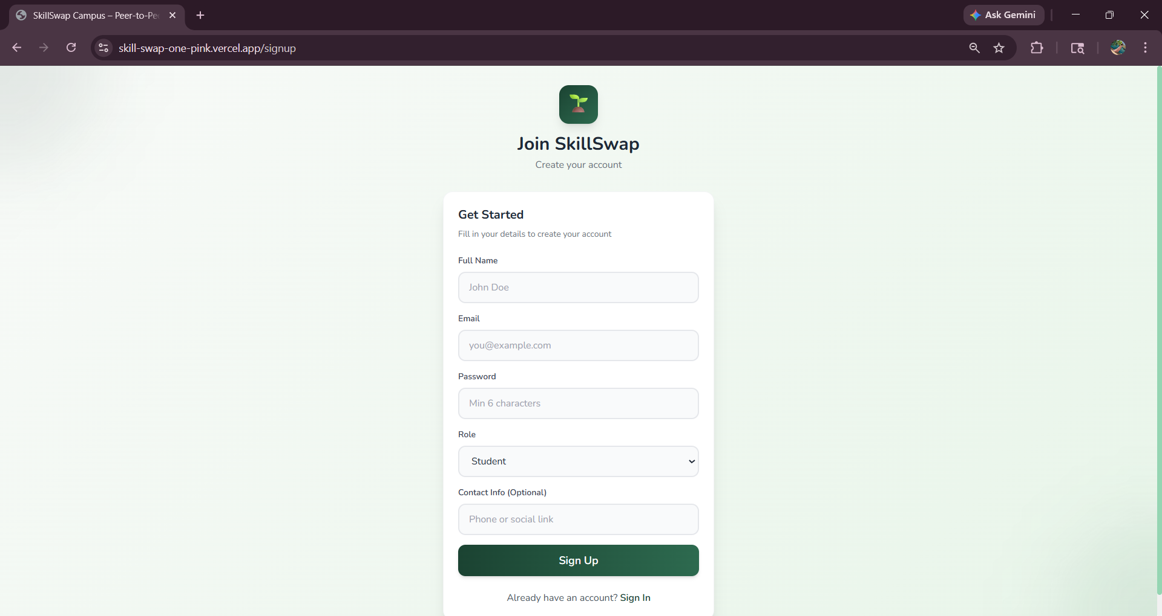

1.1 SIGNUP PAGE

3.1.2 Student Dashboard Module

The Student Dashboard serves as the central hub for users to manage their peer-learning activities. It provides a personalized overview of the student's profile, including their earned skill points and quick access to their teaching and learning schedules. From here, students can navigate to their listed skills, track the status of pending session requests, and view recent notifications, creating a streamlined experience for both mentors and learners.

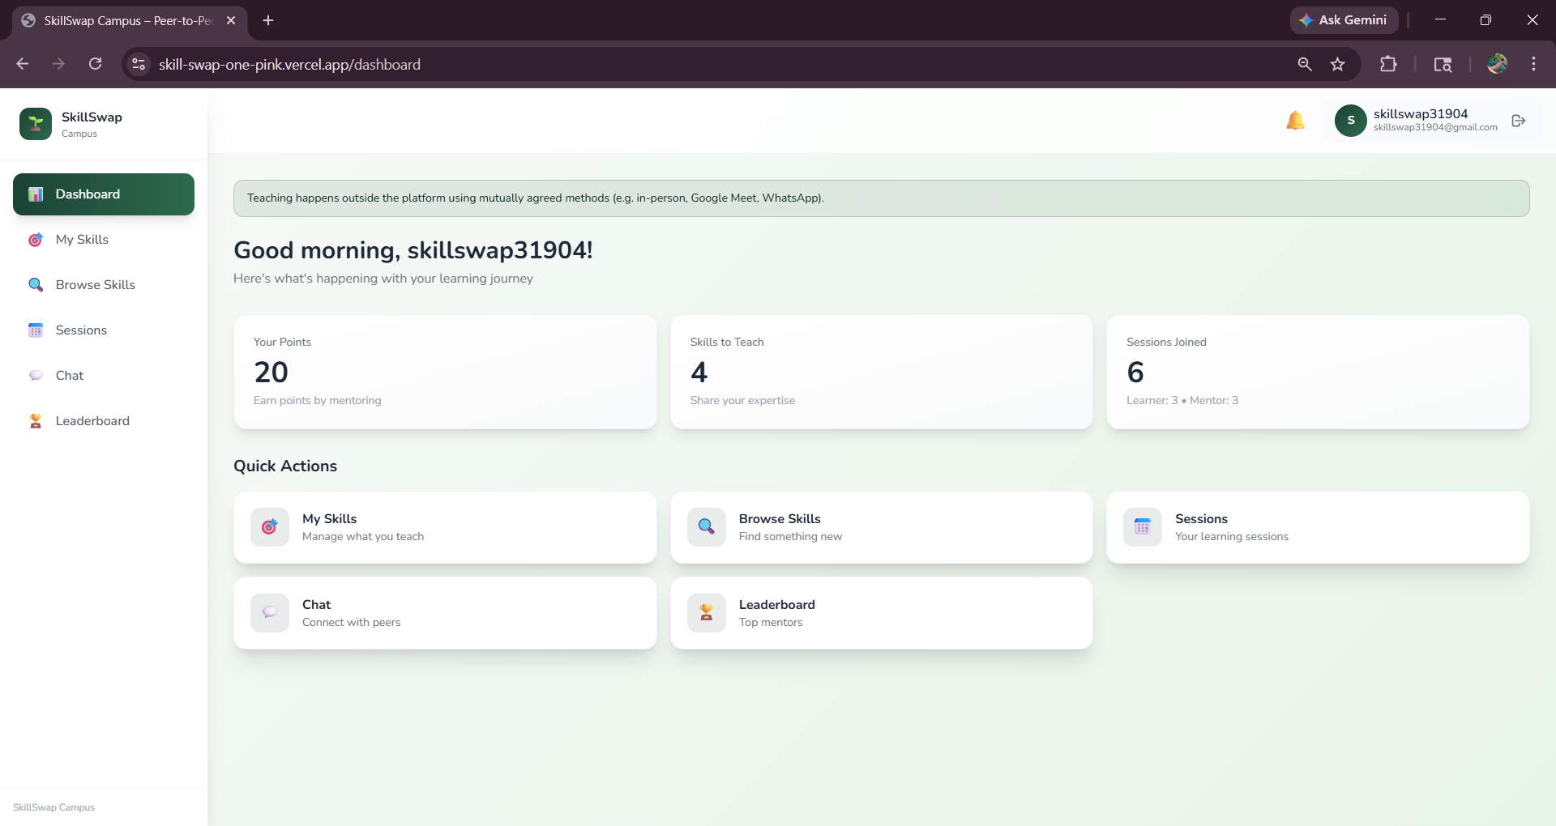

1.2 STUDENT DASHBOARD PAGE

3.1.3 Skill Management Module

This module allows students to showcase their expertise by listing skills they are willing to teach others. Students can create, update, and delete skill entries, categorizing them (e.g., Technical, Creative, Academic) to make them easily discoverable by others. It also includes a public skill-browsing interface where learners can search for specific competencies and view the profiles of potential mentors before requesting a session.

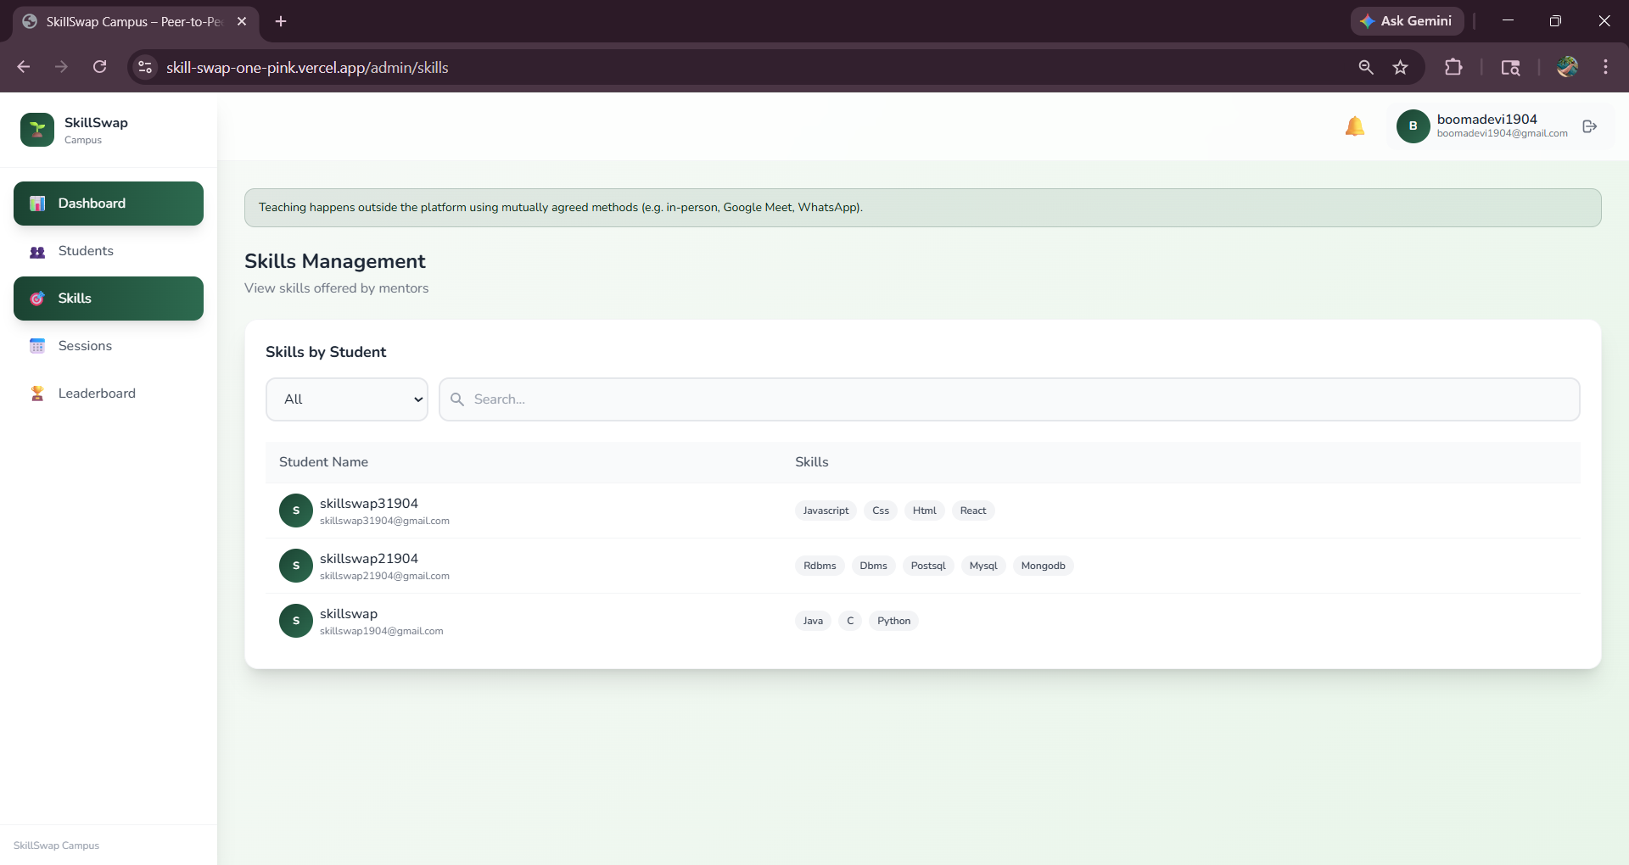

1.3 SKILL MANAGEMENT PAGE

3.1.4 Session Management Module

The Session Management module coordinates the end-to-end workflow of a learning engagement between two students. It handles the initial request (including date, time, and teaching mode), allows mentors to accept, reject, or reschedule requests, and manages the transition to a "Completed" status. Once a session is finished, this module triggers the logic to award points to the mentor and opens the feedback loop for both parties.

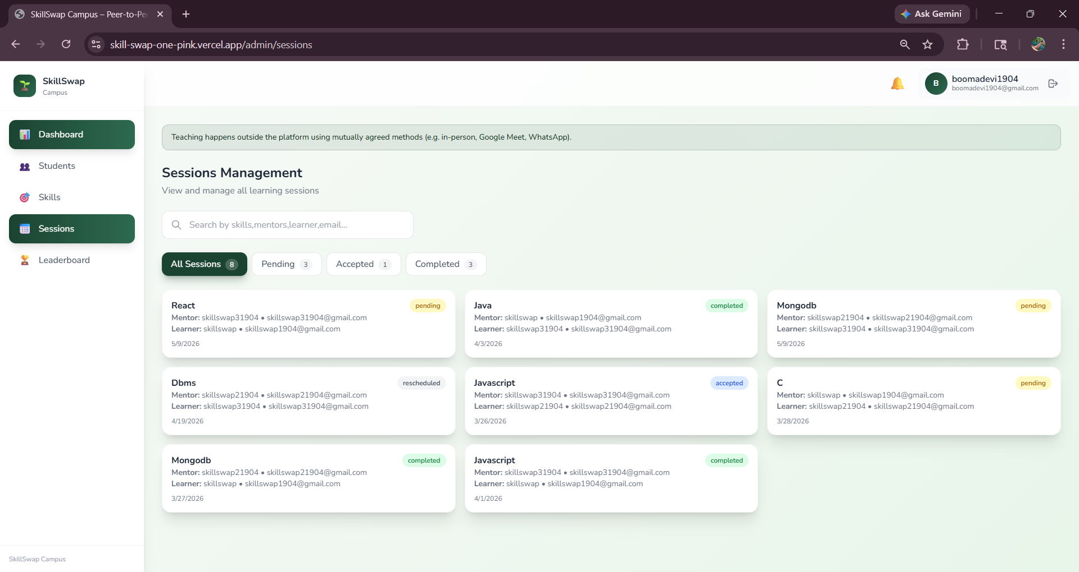

1.4 SESSION MANAGEMENT PAGE

3.1.5 Chat Module

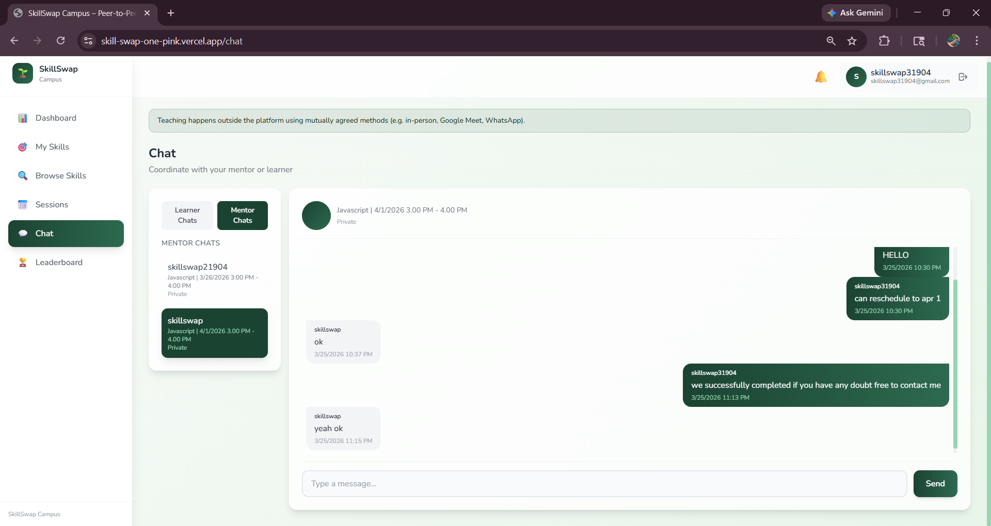
The Chat Module facilitates direct communication between a learner and a mentor once a session request has been accepted. It uses a database-driven messaging system that enables real-time text exchange, allowing users to discuss session details, share external meeting links (like Google Meet or WhatsApp), and coordinate their learning materials. To maintain privacy and focus, chat rooms are strictly tied to specific sessions and are only accessible to the authorized participants.

1.5 CHAT PAGE

3.1.6 Points & Leaderboard Module

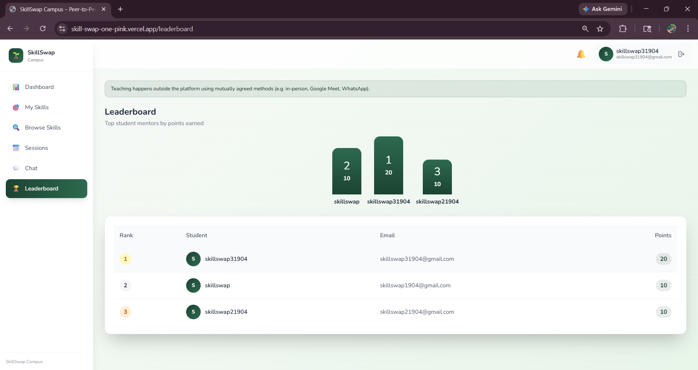
This module gamifies the mentorship experience by tracking "Skill Points" earned by students for their teaching contributions. Every successfully completed session awards a fixed number of points to the mentor, which are then used to rank users on a campus-wide leaderboard. This encourages active participation and recognizes top contributors, fostering a culture of knowledge sharing and healthy academic competition within the university.

1.6 LEADERBOARD PAGE

3.1.7 Notification Module

The Notification Module keeps users informed of all critical platform activities through real-time in-app alerts and dropdown summaries. It triggers automated messages for events such as new session requests, status updates (accepted/rescheduled), and reminders for pending actions like confirming session completion. By centralizing these alerts, the module ensures that students and admins never miss important updates regarding their mentorship commitments.

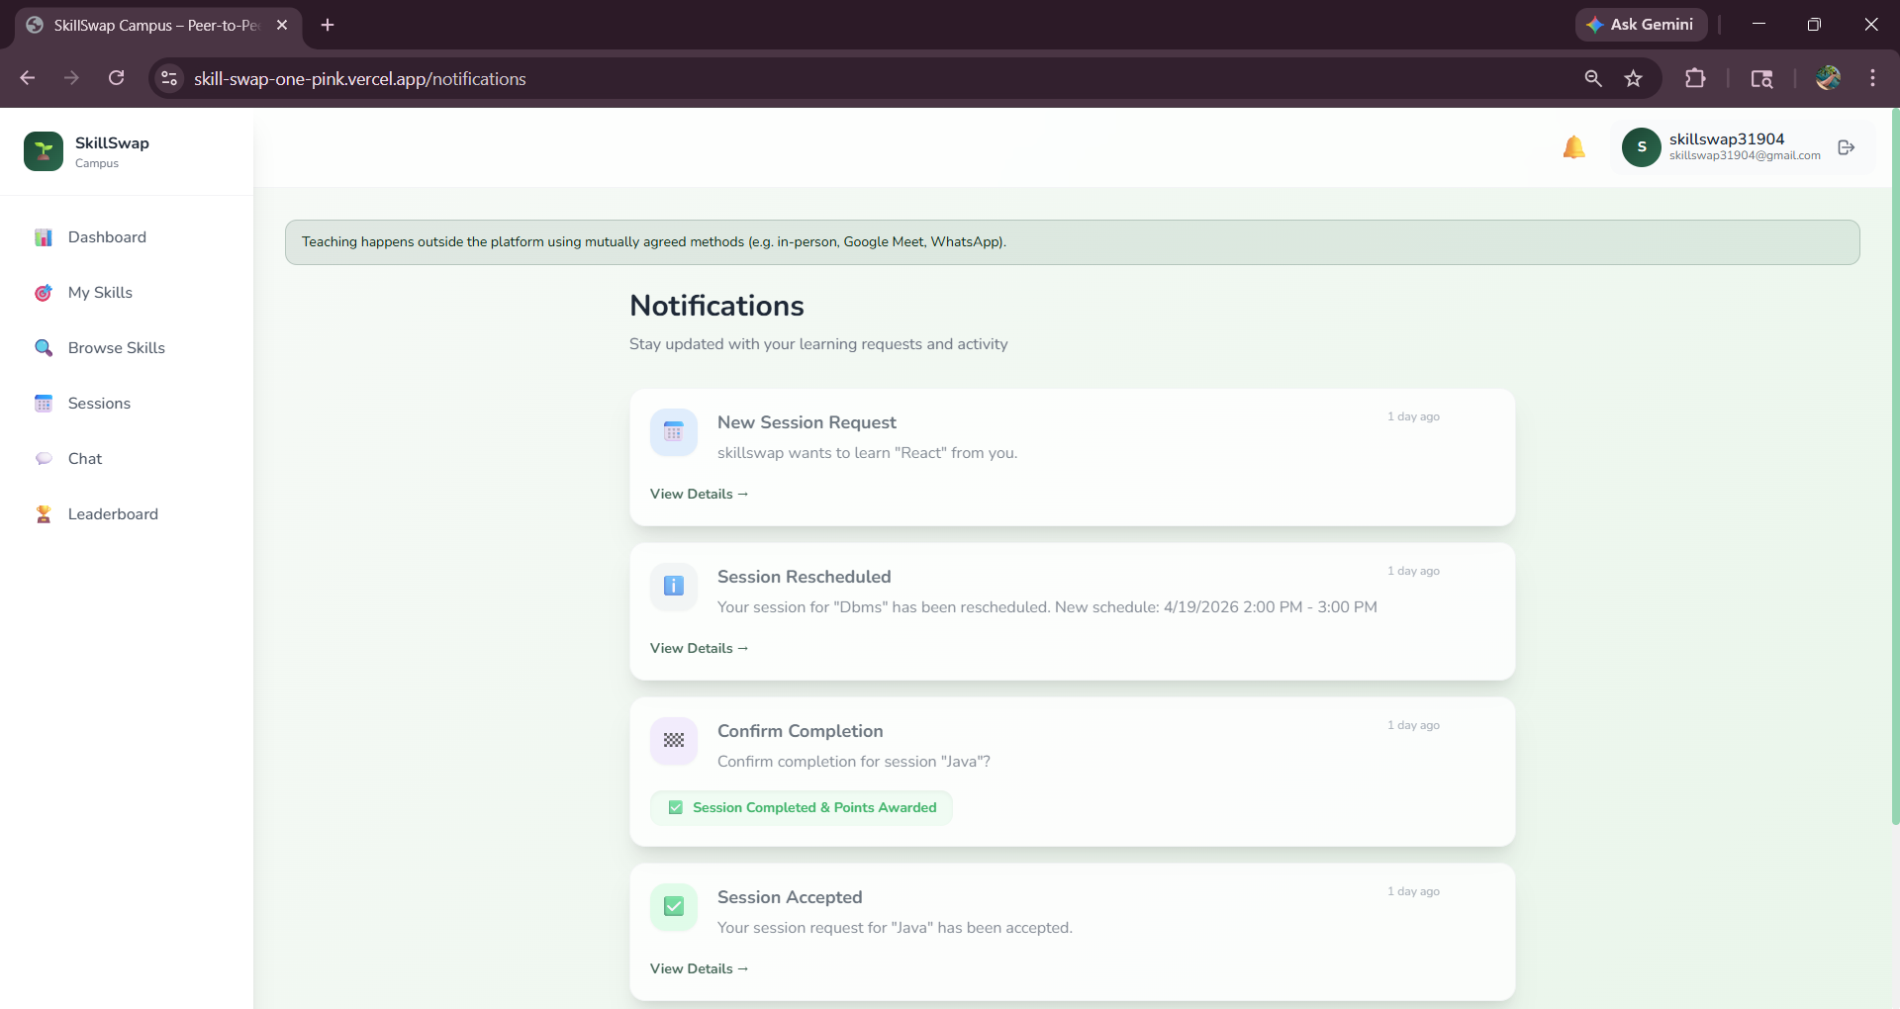

1.7 NOTIFICATION PAGE

3.1.8 Database Module

The Database Module serves as the persistent storage layer of the application, utilizing MongoDB with Mongoose for structured data modeling. It defines the schemas and relationships for Users, Skills, Sessions, Chats, and Notifications, ensuring data integrity and efficient retrieval. Through its middleware and validation logic, it handles complex operations like cascading updates for point totals and maintaining historical records of all peer-to-peer interactions across the platform.
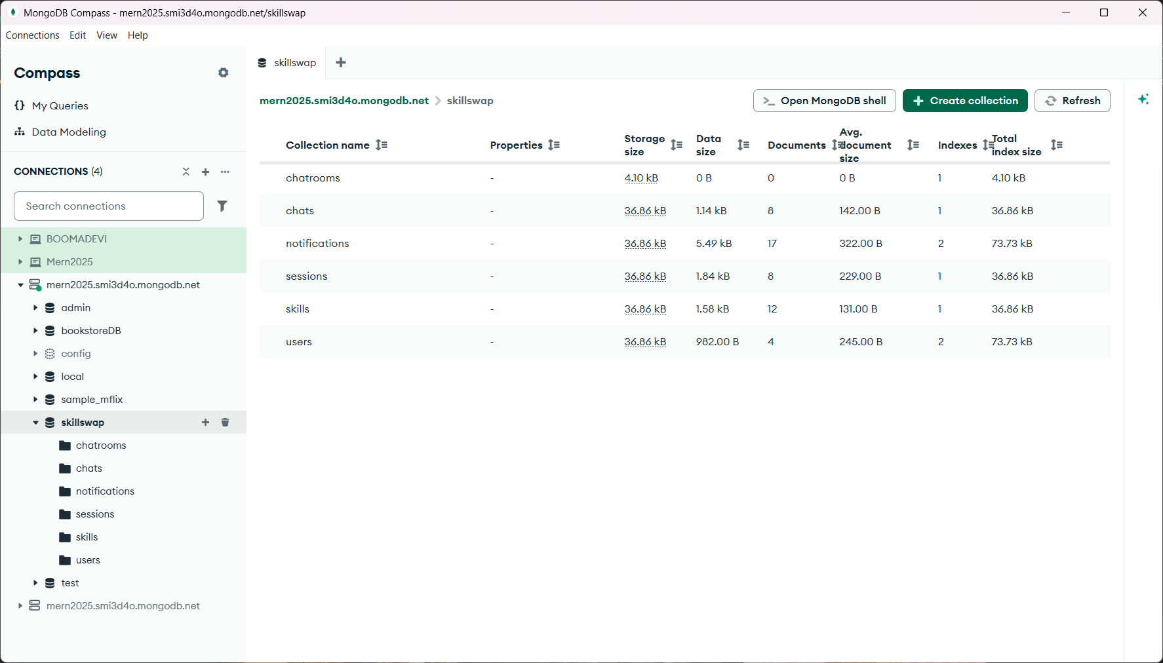

1.8 DATBASE SCREEN

CHAPTER 4

RESULT

The Skill Swap Campus project has successfully established a comprehensive peer-to-peer learning platform that enables university students to seamlessly exchange skills within a secure, faculty-monitored ecosystem. By providing dedicated interfaces for both students and administrators, the platform allows users to transition between being learners and mentors through a structured session management workflow. Students can list their expertise in a searchable marketplace, request personalized teaching sessions with defined modes of instruction—such as in-person or online—and coordinate their learning through an integrated, session-specific chat system that ensures privacy and organizational clarity throughout the engagement.

Technically, the project achieves high performance and security by utilizing a decoupled architecture with a React-Vite frontend and a Node.js-Express backend, all backed by a scalable MongoDB database. The implementation of JWT-based authentication and an email-linked OTP verification system ensures that only verified campus members can access the platform, while a gamified Skill Points and leaderboard module incentivizes active mentorship. This results in a robust academic tool that not only fosters community building and knowledge sharing but also provides administrators with the necessary oversight tools to track campus-wide engagement and recognize top student contributors.

CHAPTER 5

CONCLUSION AND FUTURE WORK

In conclusion, the Skill Swap Campus project has successfully addressed the need for a structured, university-centric peer-learning ecosystem by delivering a robust full-stack platform. By integrating secure authentication, a dynamic skill marketplace, and a gamified points system, the application effectively transforms the campus into a collaborative community where students are empowered to both teach and learn. The platform not only streamlines the logistical challenges of scheduling and communication through its automated session workflows and integrated chat but also provides faculty with the oversight tools necessary to maintain a productive academic environment, ultimately fostering a culture of voluntary knowledge exchange and professional growth.

For future work, the platform is poised for several strategic enhancements to further deepen student engagement and scalability. Key areas for development include the integration of real-time WebSocket’s for instantaneous messaging, the implementation of a mobile application using React Native for on-the-go access, and an AI-driven recommendation engine to suggest skills and mentors based on a student's interests and learning history. Additionally, expanding the platform to support group workshops and integrating a video conferencing API like Jitsi or Zoom directly into the interface would provide a more comprehensive, all-in-one virtual learning experience that transcends physical campus boundaries.

APPENDIX 1

CODING

App.jsx :

import React from "react";
import { Routes, Route, Navigate } from "react-router-dom";
import { useAuth } from "./context/AuthContext";
import Layout from "./components/Layout";
import Login from "./pages/Login";
import Signup from "./pages/Signup";
import VerifyOTP from "./pages/VerifyOTP";
import ForgotPassword from "./pages/ForgotPassword";
import ResetPassword from "./pages/ResetPassword";
import StudentDashboard from "./pages/StudentDashboard";
import SkillProfile from "./pages/SkillProfile";
import SkillListing from "./pages/SkillListing";
import SessionRequests from "./pages/SessionRequests";
import Chat from "./pages/Chat";
import AdminDashboard from "./pages/AdminDashboard";
import Leaderboard from "./pages/Leaderboard";
import Notifications from "./pages/Notifications";
import { Toaster } from "react-hot-toast";

function HomeRedirect() {
const { user } = useAuth();
return <Navigate to={user?.role === "admin" ? "/admin" : "/dashboard"} replace />;
}

function PrivateRoute({ children, studentOnly, adminOnly }) {
const { user, loading } = useAuth();
if (loading) {
return (
<div className="min-h-screen flex items-center justify-center bg-surface">
<div className="text-primary font-medium">Loading...</div>
</div>
);
}
if (!user) return <Navigate to="/login" replace />;
if (studentOnly && user.role !== "student") return <Navigate to="/admin" replace />;
if (adminOnly && user.role !== "admin") return <Navigate to="/dashboard" replace />;
return children;
}

export default function App() {
return (
<>
<Toaster position="top-right" />
<Routes>
<Route path="/login" element={<Login />} />
<Route path="/signup" element={<Signup />} />
<Route path="/verify-otp" element={<VerifyOTP />} />
<Route path="/forgot-password" element={<ForgotPassword />} />
<Route path="/reset-password" element={<ResetPassword />} />
<Route
path="/"
element={
<PrivateRoute>
<Layout />
</PrivateRoute>
}
>
<Route index element={<HomeRedirect />} />
<Route path="dashboard" element={<PrivateRoute studentOnly><StudentDashboard /></PrivateRoute>} />
<Route path="skills" element={<PrivateRoute studentOnly><SkillProfile /></PrivateRoute>} />
<Route path="browse" element={<PrivateRoute studentOnly><SkillListing /></PrivateRoute>} />
<Route path="sessions" element={<PrivateRoute studentOnly><SessionRequests /></PrivateRoute>} />
<Route path="chat" element={<PrivateRoute studentOnly><Chat /></PrivateRoute>} />
<Route path="chat/:sessionId" element={<PrivateRoute studentOnly><Chat /></PrivateRoute>} />
<Route path="leaderboard" element={<PrivateRoute studentOnly><Leaderboard /></PrivateRoute>} />
<Route path="notifications" element={<PrivateRoute studentOnly><Notifications /></PrivateRoute>} />
<Route path="admin" element={<PrivateRoute adminOnly><AdminDashboard /></PrivateRoute>} />
<Route path="admin/students" element={<PrivateRoute adminOnly><AdminDashboard tab="students" /></PrivateRoute>} />
<Route path="admin/skills" element={<PrivateRoute adminOnly><AdminDashboard tab="skills" /></PrivateRoute>} />
<Route path="admin/sessions" element={<PrivateRoute adminOnly><AdminDashboard tab="sessions" /></PrivateRoute>} />
<Route path="admin/leaderboard" element={<PrivateRoute adminOnly><AdminDashboard tab="leaderboard" /></PrivateRoute>} />
</Route>
<Route path="*" element={<Navigate to="/" replace />} />
</Routes>
</>
);
}

StudentDashboard.jsx:

import React, { useEffect, useState } from "react";

import { Link } from "react-router-dom";

import { useAuth } from "../context/AuthContext";

import { api } from "../api";

export default function StudentDashboard() {

const { user, updateUser } = useAuth();

const [mySkillsCount, setMySkillsCount] = useState(0);

const [sessionsLearnerCount, setSessionsLearnerCount] = useState(0);

const [sessionsMentorCount, setSessionsMentorCount] = useState(0);

useEffect(() => {

api.get("/api/auth/me").then((r) => updateUser(r.data)).catch(() => {});

}, [updateUser]);

useEffect(() => {

if (!user) return;

api

.get("/api/skills/my")

.then((r) => setMySkillsCount((r.data || []).length))

.catch(() => setMySkillsCount(0));

api

.get("/api/sessions/my")

.then((r) => {

const asLearner = ((r.data && r.data.asLearner) || []);

const asMentor = ((r.data && r.data.asMentor) || []);

setSessionsLearnerCount(asLearner.length);

setSessionsMentorCount(asMentor.length);

})

.catch(() => {

setSessionsLearnerCount(0);

setSessionsMentorCount(0);

});

}, [user]);

const getGreeting = () => {

const hour = new Date().getHours();

if (hour < 12) return "Good morning";

if (hour < 17) return "Good afternoon";

return "Good evening";

};

const stats = [

{ label: "Your Points", value: user?.points ?? 0, description: "Earn points by mentoring" },

{ label: "Skills to Teach", value: mySkillsCount || 0, description: "Share your expertise" },

{ label: "Sessions Joined", value: (sessionsLearnerCount + sessionsMentorCount) || 0, description: `Learner: ${sessionsLearnerCount} • Mentor: ${sessionsMentorCount}` },

];

const quickLinks = [

{ to: "/skills", label: "My Skills", desc: "Manage what you teach", icon: "🎯" },

{ to: "/browse", label: "Browse Skills", desc: "Find something new", icon: "🔍" },

{ to: "/sessions", label: "Sessions", desc: "Your learning sessions", icon: "📅" },

{ to: "/chat", label: "Chat", desc: "Connect with peers", icon: "💬" },

{ to: "/leaderboard", label: "Leaderboard", desc: "Top mentors", icon: "🏆" },

];

return (

<div className="animate-fade-in">

{/* Welcome section */}

<div className="mb-8">

<h1 className="text-3xl font-bold text-gray-800">

{getGreeting()}, {user?.name?.split(" ")[0]}!

</h1>

<p className="text-gray-500 mt-1">Here's what's happening with your learning journey</p>

</div>

{/* Stats grid */}

<div className="grid gap-4 sm:grid-cols-2 lg:grid-cols-3 mb-8">

{stats.map((stat, index) => (

<div

key={stat.label}

className="stat-card animate-fade-in"

style={{ animationDelay: `${index * 100}ms` }}

>

<div className="flex items-start justify-between">

<div>

<p className="text-gray-500 text-sm font-medium">{stat.label}</p>

<p className="text-4xl font-bold text-gray-800 mt-2">{stat.value}</p>

<p className="text-gray-400 text-sm mt-1">{stat.description}</p>

</div>

</div>

</div>

))}

</div>

{/* Quick links */}

<h2 className="text-xl font-bold text-gray-800 mb-4">Quick Actions</h2>

<div className="grid gap-4 sm:grid-cols-2 lg:grid-cols-3">

{quickLinks.map((link, index) => (

<Link

key={link.to}

to={link.to}

className={`card-elevated p-5 group animate-fade-in flex items-center gap-4`}

style={{ animationDelay: `${(index + 3) * 100}ms` }}

>

<div className="w-12 h-12 rounded-xl bg-primary/10 flex items-center justify-center text-xl transition-transform group-hover:scale-110">

{link.icon}

</div>

<div>

<h3 className="font-bold text-gray-800 group-hover:text-primary transition-colors">

{link.label}

</h3>

<p className="text-gray-500 text-sm">{link.desc}</p>

</div>

</Link>

))}

</div>

</div>

);

}

Login.jsx :

import React, { useState } from "react";
import { Link, useNavigate } from "react-router-dom";
import { useAuth } from "../context/AuthContext";
import { api } from "../api";

export default function Login() {
const [email, setEmail] = useState("");
const [password, setPassword] = useState("");
const [error, setError] = useState("");
const [loading, setLoading] = useState(false);
const { login } = useAuth();
const navigate = useNavigate();

const handleSubmit = async (e) => {
e.preventDefault();
setError("");
setLoading(true);
try {
const res = await api.post("/api/auth/login", { email, password });
const data = res.data;
login(data.user, data.token);
navigate(data.user.role === "admin" ? "/admin" : "/dashboard");
} catch (err) {
setError(err.response?.data?.error || err.message || "Login failed");
setLoading(false);
}
};

return (
<div className="min-h-screen flex items-center justify-center p-4">
{/* Background decoration */}
<div className="absolute inset-0 overflow-hidden pointer-events-none">
<div className="absolute -top-40 -right-40 w-80 h-80 bg-primary/10 rounded-full blur-3xl" />
<div className="absolute -bottom-40 -left-40 w-80 h-80 bg-primary-light/10 rounded-full blur-3xl" />
</div>

<div className="relative w-full max-w-md">
{/* Logo */}
<div className="text-center mb-8">
<div className="inline-flex items-center justify-center w-16 h-16 rounded-2xl bg-gradient-to-br from-primary to-primary-light text-white text-3xl mb-4 shadow-lg">
🌱
</div>
<h1 className="text-3xl font-bold text-gray-800">SkillSwap Campus</h1>
<p className="text-gray-500 mt-1">Peer-to-Peer Learning</p>
</div>

<div className="card-elevated">
<h2 className="text-xl font-bold text-gray-800 mb-2">Welcome back!</h2>
<p className="text-gray-500 text-sm mb-6">Enter your details to access your account</p>

{error && (
<div className="bg-red-50 border border-red-200 text-red-700 px-4 py-3 rounded-xl text-sm flex items-center gap-2 mb-4">
<span>⚠️</span>
{error}
</div>
)}

<form onSubmit={handleSubmit} className="space-y-4">
<div>
<label className="block text-sm font-semibold text-gray-700 mb-2">Email</label>
<input
type="email"
value={email}
onChange={(e) => setEmail(e.target.value)}
className="input-field"
placeholder="you@example.com"
required
/>
</div>

<div>
<label className="block text-sm font-semibold text-gray-700 mb-2">Password</label>
<input
type="password"
value={password}
onChange={(e) => setPassword(e.target.value)}
className="input-field"
placeholder="••••••••"
required
/>
</div>

<div className="flex justify-end mt-1">
<Link to="/forgot-password" size="sm" className="text-sm text-primary hover:underline">
Forgot password?
</Link>
</div>

<button
type="submit"
className="btn-primary w-full py-3 text-lg mt-4"
disabled={loading}
>
{loading ? "Signing in..." : "Sign In"}
</button>
</form>

<p className="mt-6 text-center text-gray-600">
Don't have an account?{" "}
<Link to="/signup" className="text-primary font-semibold hover:underline">
Create one
</Link>
</p>
</div>
</div>
</div>
);
}

Signup.jsx:

import React, { useState } from "react";

import { Link, useNavigate } from "react-router-dom";

import { api } from "../api";

export default function Signup() {

const [name, setName] = useState("");

const [email, setEmail] = useState("");

const [password, setPassword] = useState("");

const [role, setRole] = useState("student");

const [contact, setContact] = useState("");

const [error, setError] = useState("");

const [loading, setLoading] = useState(false);

const navigate = useNavigate();

const handleSubmit = async (e) => {

e.preventDefault();

setError("");

setLoading(true);

try {

await api.post("/api/auth/signup", {

name,

email,

password,

role,

contact: contact || undefined,

});

// Instead of logging in, redirect to OTP verification

navigate("/verify-otp", { state: { email } });

} catch (err) {

const msg = err.response?.data?.error || err.response?.data?.errors?.[0]?.msg || err.message;

setError(msg || "Signup failed");

setLoading(false);

}

};

return (

<div className="min-h-screen flex items-center justify-center p-4 py-8">

{/* Background decoration */}

<div className="absolute inset-0 overflow-hidden pointer-events-none">

<div className="absolute -top-40 -left-40 w-80 h-80 bg-primary/10 rounded-full blur-3xl" />

<div className="absolute -bottom-40 -right-40 w-80 h-80 bg-primary-light/10 rounded-full blur-3xl" />

</div>

<div className="relative w-full max-w-md">

{/* Logo */}

<div className="text-center mb-8">

<div className="inline-flex items-center justify-center w-16 h-16 rounded-2xl bg-gradient-to-br from-primary to-primary-light text-white text-3xl mb-4 shadow-lg">

🌱

</div>

<h1 className="text-3xl font-bold text-gray-800">Join SkillSwap</h1>

<p className="text-gray-500 mt-1">Create your account</p>

</div>

<div className="card-elevated">

<h2 className="text-xl font-bold text-gray-800 mb-2">Get Started</h2>

<p className="text-gray-500 text-sm mb-6">Fill in your details to create your account</p>

{error && (

<div className="bg-red-50 border border-red-200 text-red-700 px-4 py-3 rounded-xl text-sm flex items-center gap-2 mb-4">

<span>⚠️</span>

{error}

</div>

)}

<form onSubmit={handleSubmit} className="space-y-4">

<div>

<label className="block text-sm font-semibold text-gray-700 mb-2">Full Name</label>

<input

type="text"

value={name}

onChange={(e) => setName(e.target.value)}

className="input-field"

placeholder="John Doe"

required

/>

</div>

<div>

<label className="block text-sm font-semibold text-gray-700 mb-2">Email</label>

<input

type="email"

value={email}

onChange={(e) => setEmail(e.target.value)}

className="input-field"

placeholder="you@example.com"

required

/>

</div>

<div>

<label className="block text-sm font-semibold text-gray-700 mb-2">Password</label>

<input

type="password"

value={password}

onChange={(e) => setPassword(e.target.value)}

className="input-field"

placeholder="Min 6 characters"

minLength={6}

required

/>

</div>

<div>

<label className="block text-sm font-semibold text-gray-700 mb-2">Role</label>

<select

value={role}

onChange={(e) => setRole(e.target.value)}

className="input-field"

>

<option value="student">Student</option>

<option value="admin">Admin</option>

</select>

</div>

<div>

<label className="block text-sm font-semibold text-gray-700 mb-2">Contact Info (Optional)</label>

<input

type="text"

value={contact}

onChange={(e) => setContact(e.target.value)}

className="input-field"

placeholder="Phone or social link"

/>

</div>

<button

type="submit"

className="btn-primary w-full py-3 text-lg mt-2"

disabled={loading}

>

{loading ? "Sending OTP..." : "Sign Up"}

</button>

</form>

<p className="mt-6 text-center text-gray-600">

Already have an account?{" "}

<Link to="/login" className="text-primary font-semibold hover:underline">

Sign In

</Link>

</p>

</div>

</div>

</div>

);

}

REFERENCES

- React js Documentation-React learn,https://react.dev/learn
- Node.js Documentation – OpenJS Foundation, https://nodejs.org/en/docs
- Express.js Guide – Express.js Official Site, https://expressjs.com/
- MongoDB Manual – MongoDB Inc., https://www.mongodb.com/docs/manual/
- Genai - IBM Official Site,https://www.ibm.com/think/topics/generative-ai
- Host Link - https://skill-swap-one-pink.vercel.app/
- GIT HUB : https://github.com/boomadevi-1904/Skill-Swap.git

